UNITED NATIONS DEVELOPMENT PROGRAMME
FUNDING COMPENDIUM 2025

Contents
Lorem ipsum

Foreword

Sustaining Trust in an Era of Uncertainty

Foreword is under review

Funding landscape

Executive summary
The Funding Compendium presents the annual contributions received by UNDP from its funding partners through various channels. These include regular (core) resources and other resources and range from softly earmarked thematic funds to tightly earmarked funds for specific programmes or projects.
The year 2025 tested UNDP’s agility, resilience and ability to respond to complexity. During the global decline in official development assistance (ODA) in 2025, UNDP’s annual contributions from its partners remained broadly stable at $5 billion, a 2 percent increase compared to 2024. However, despite this overall stability, the quality of funding continued to deteriorate. In 2025, regular resources declined to $442 million, down by 24 percent from $581 million in 2024.
Despite the record-low level of regular resources received in 2025, UNDP delivered $4.9 billion in programme expenditure, allocated 91 cents of every programmatic dollar to development activities and continued to demonstrate the catalytic value of regular resources by mobilizing approximately $10 in other resources for every $1 of core funding.
The declining trend in regular resources increasingly constrains UNDP’s ability to adequately support country programming, respond to crises, invest in innovation and maintain the institutional capabilities that underpin integrated development solutions.
- Total annual contributions to UNDP: Annual contributions increased to $5 billion in 2025, up by 2 percent from $4.9 billion in 2024. Of this total, $1.8 billion (36 percent) was from donor country governments; $1.6 billion (32 percent) was from multilateral partners, and $1.6 billion (32 percent) was from programme country governments.
- Regular resources: Annual contributions to regular resources decreased to $442 million, down by 24 percent from $581 million in 2024. Their share of total annual contributions decreased to 9 percent from 12 percent in 2024 and remains far below the Funding Compact target of 30 percent. Multi-year commitments amounted to $165 million, or 37 percent of regular resource contributions, down from 40 percent in 2024.
- Other resources: Annual contributions to other resources increased to $4.6 billion, up by 6 percent from $4.3 billion in 2024.
¹ In 2019, UNDP refined its accounting policy on IPSAS 23 (non-exchange) revenues. Under this policy, UNDP records the full value of funding agreements when they are signed, even when cash has not been received for most contribution agreements. Uncollected cash is held as a receivable. However, UNDP may spend only up to the amount of cash received. Where applicable, “annual contributions” are therefore aligned with past revenue-recognition policies: cash received in a reporting year plus receivables due in that year.

Financial Highlights, 2025

17% increase in government development financing
Contributions from government financing increased to $1.4 billion in 2025,
down from $1.2 billion in 2024 and representing 28% of total resources

24% decrease in core funding (regular resources)
Core contributions decreased to $442 million in 2025,
down from $581 million in 2024

14% decrease in funding windows
Contributions from thematic funding windows decreased to $115 million in 2025,
down from $133 million in 2024

10 partners* had multi-year pledges to contribute regular resources
Belgium, Canada, Denmark, Luxembourg, Ireland,
The Netherlands, New Zealand, Qatar, Sweden and Türkiye
*Australia had a multi-year core agreement in 2025 but did not contribute to core funding.

4 partners increased their contributions to regular resources
Spain, Luxembourg, Belgium and Austria

Commitment to transparency and accountability
A long-standing commitment to transparency
As a member of the International Aid Transparency Initiative (IATI) since its creation in 2008, UNDP has led outreach efforts with partner countries and UN agencies to champion the aid transparency standard and make it relevant to national development planning, public financial management and mutual accountability for aid, development and humanitarian funding. UNDP ranked sixth overall in the 2024 Aid Transparency Index and was the second-most-transparent UN agency. UNDP’s Transparency Portal allows open, comprehensive public access to data on over 4,000 UNDP projects, with links to profile pages for every donor. The portal also shows UNDP’s contribution to the SDGs and offers an online training platform on the IATI Standard.

Promoting transparency across the UN system
UNDP actively participated in defining and implementing a set of UN data standards for system-wide financial reporting.

Audit reports
UNDP has been publishing audit reports issued by the Office of Audit and Investigations since 2012, and has obtained its 20th consecutive unqualified (clean) audit from the UN Board of Auditors.

Resources by funding type

Annual contributions increased to $5 billion in 2025, up by 2 percent from $4.9 billion in 2024.
Annual contributions to regular resources decreased to $442 million, down by 24 percent from $581 million in 2024.
Annual contributions to other resources increased to $4.6 billion, up by 6 percent from $4.3 billion in 2024.

Annual contributions by funding type, 2025
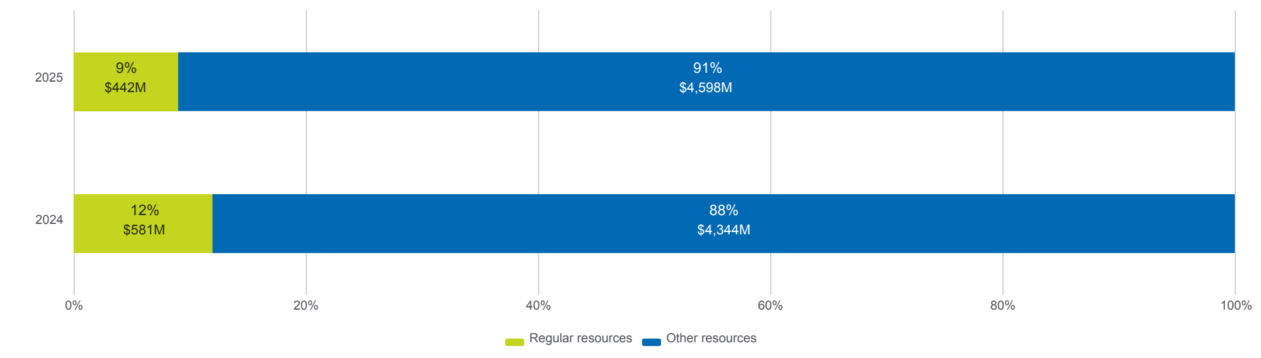

Regular resources are critical to UNDP’s ability to prioritize countries’ needs, respond swiftly in crises and maintain high standards of accountability and transparency. They also allow UNDP to sustain country presence and upstream policy expertise that other types of funding cannot support. Regular resources also carry strong catalytic value, mobilizing additional other resources (non-core). Insufficient regular resources would therefore severely compromise UNDP’s unique ability to respond rapidly to emergencies and address critical needs that other funding sources do not cover. The decline in regular resources also has serious implications for UNDP’s ability to deliver the intended results of the Strategic Plan, restore and accelerate progress towards the Sustainable Development Goals (SDGs) and maintain robust oversight and accountability systems.
Trends in regular and other resources, 2022–2025 UNDP maintained broadly stable annual contributions throughout the period covered by the 2022–2025 Strategic Plan, averaging approximately $4.9 billion per year. Annual contributions reached a peak of $5.0 billion in both 2023 and 2025.
Trends in regular and other resources, 2022-2025
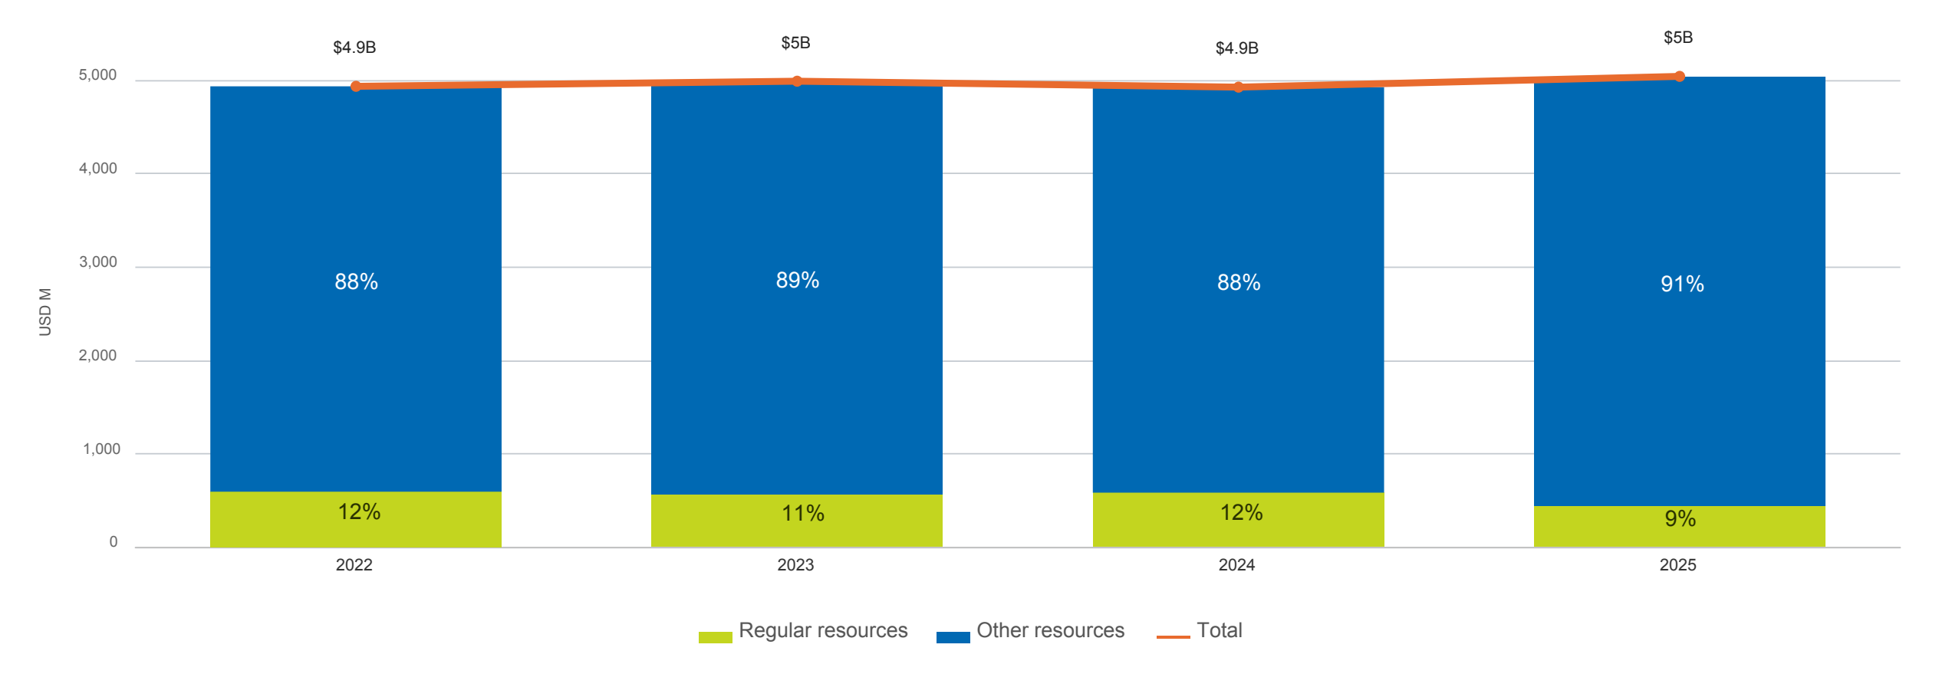

Resources by funding partner
UNDP values all types of funding received from its partners—including Member States, multilateral organizations, non-governmental organizations, private and philanthropic organizations and financing institutions—as these resources enable it to deliver on its commitments. In 2025, UNDP received total annual contributions of $5 billion. Of this total, 36 percent was contributed by donor country governments, 32 percent by multilateral organizations, and 32 percent by programme country governments.
Resources by partner group, 2025
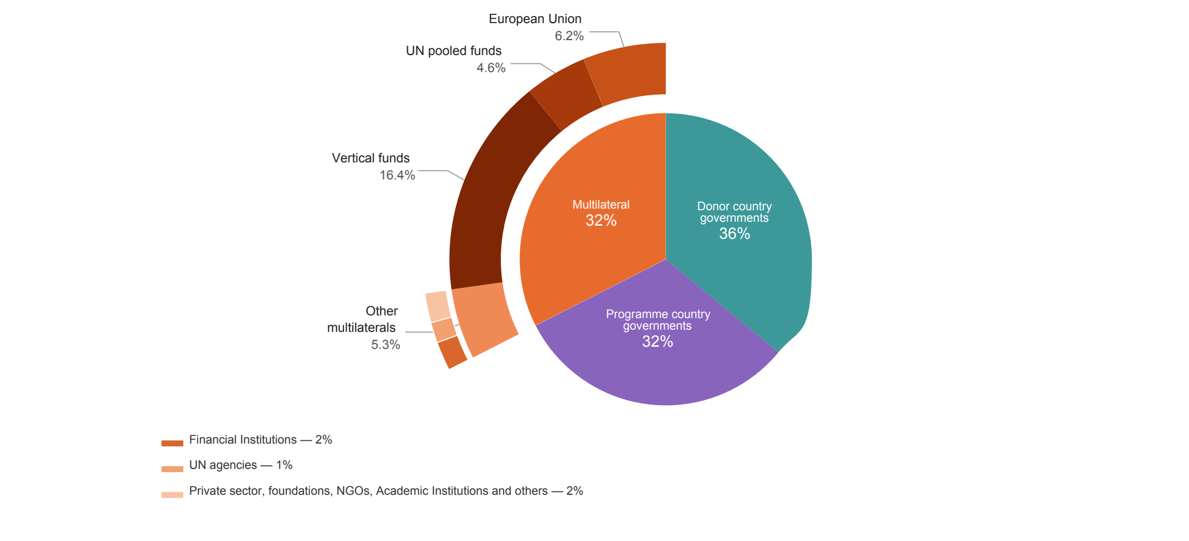

Top 30 resource partners, 2025
In 2025, UNDP’s top 30 resource partners contributed $4.1 billion, or 82 percent of total annual contributions. These partners provided 89 percent of regular resources and 81 percent of other resource contributions.
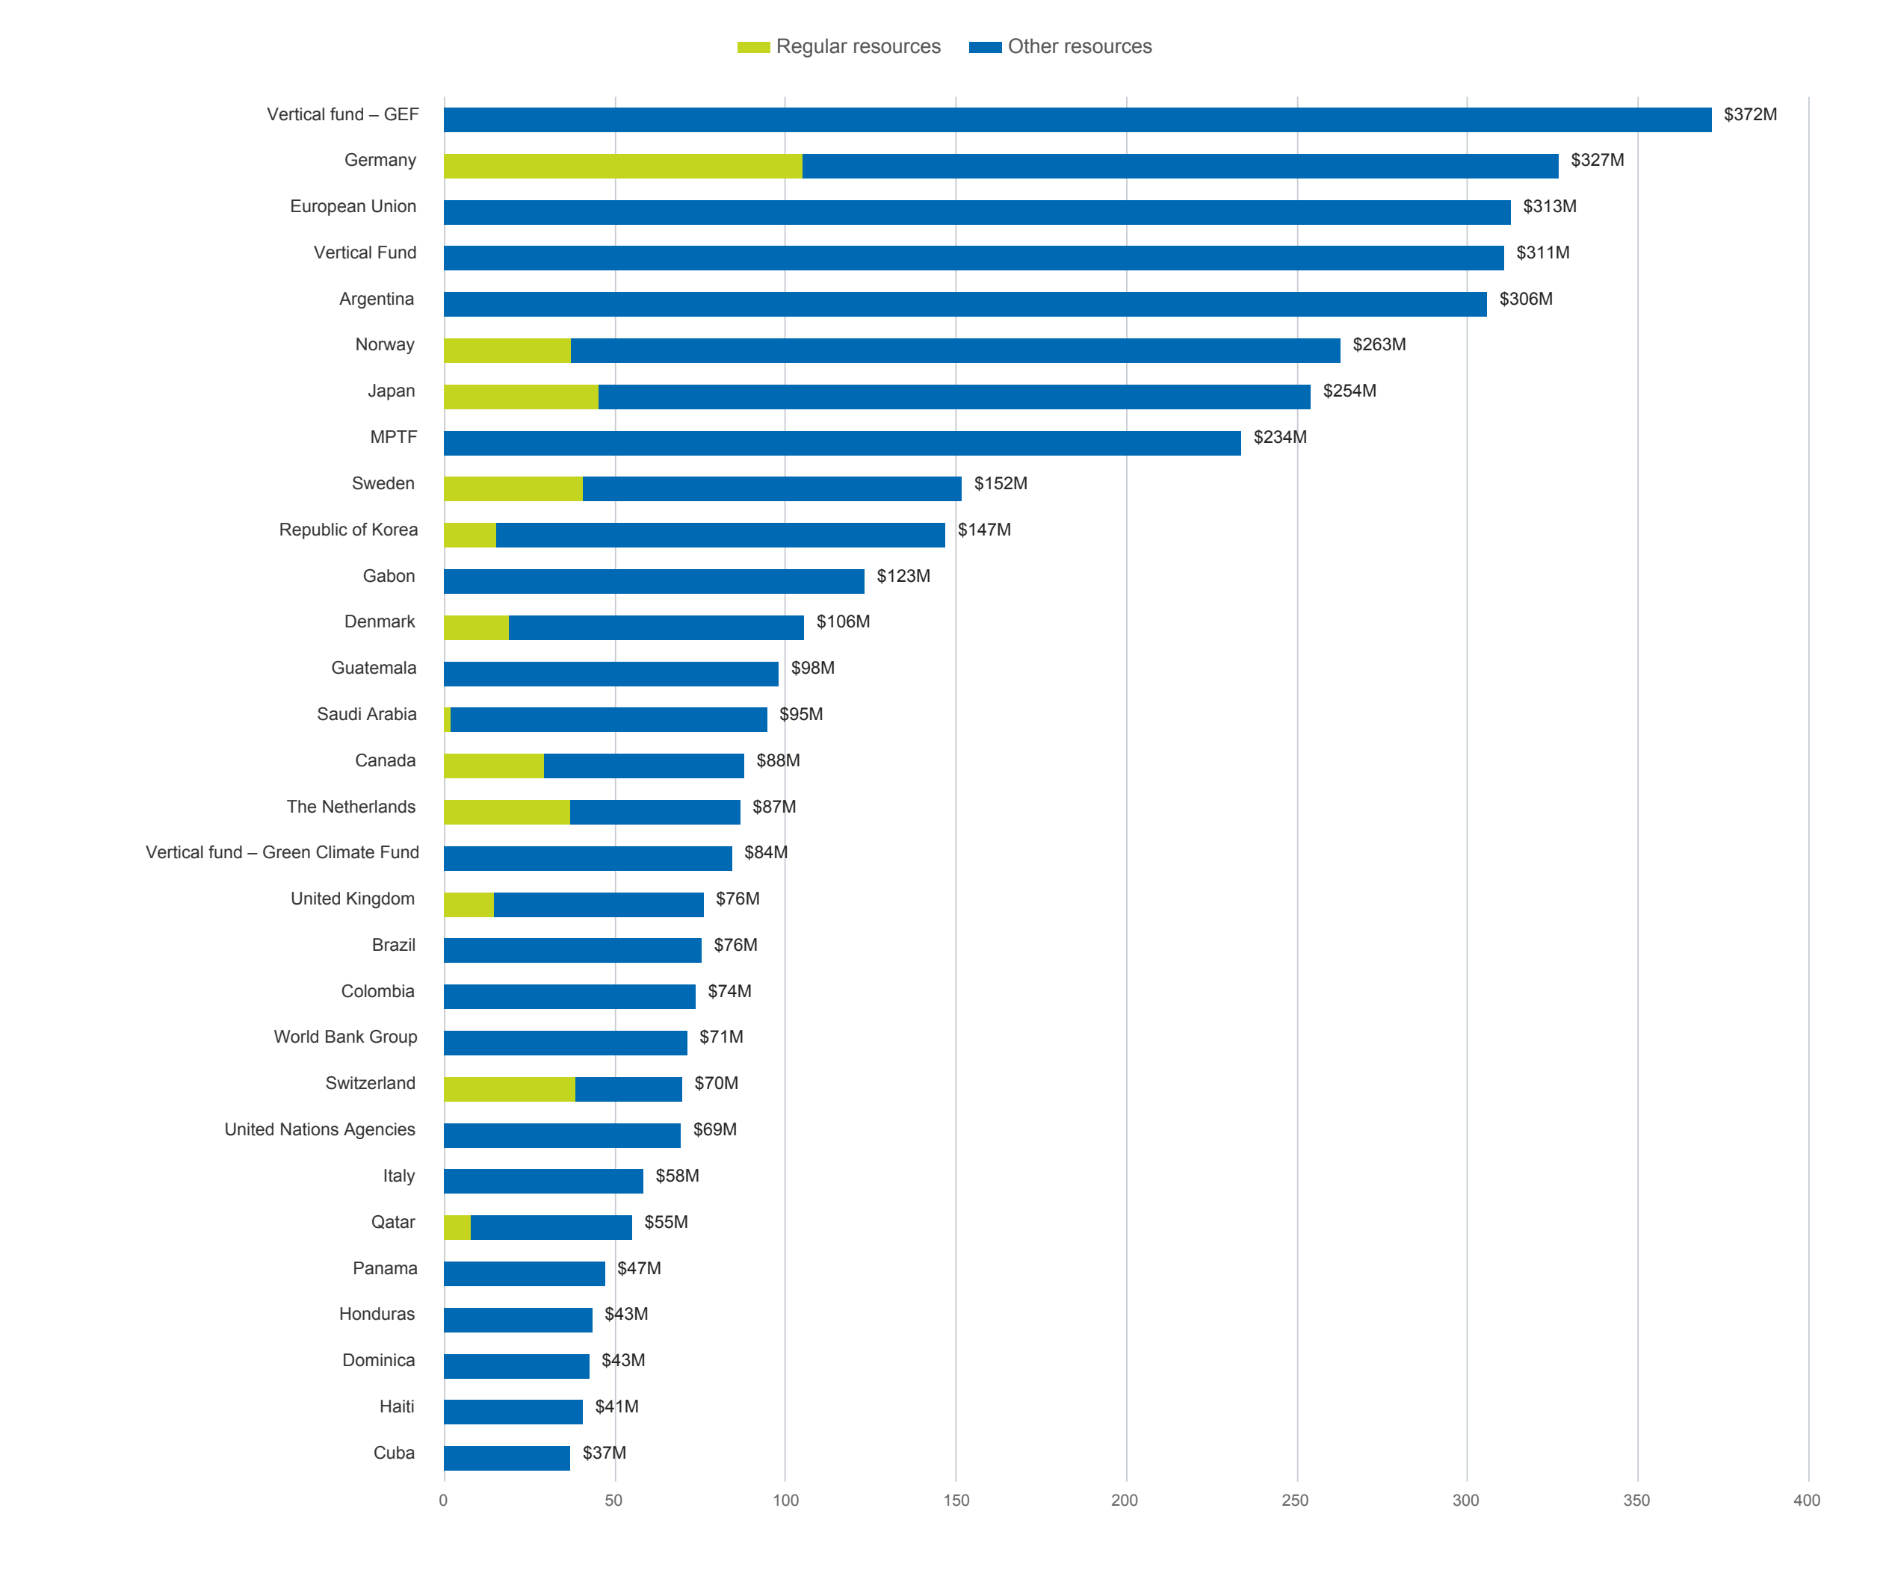

Resources by funding channel
In 2025, UNDP benefited from increases in government development financing (17 percent)
and third-party cost-sharing (7 percent).
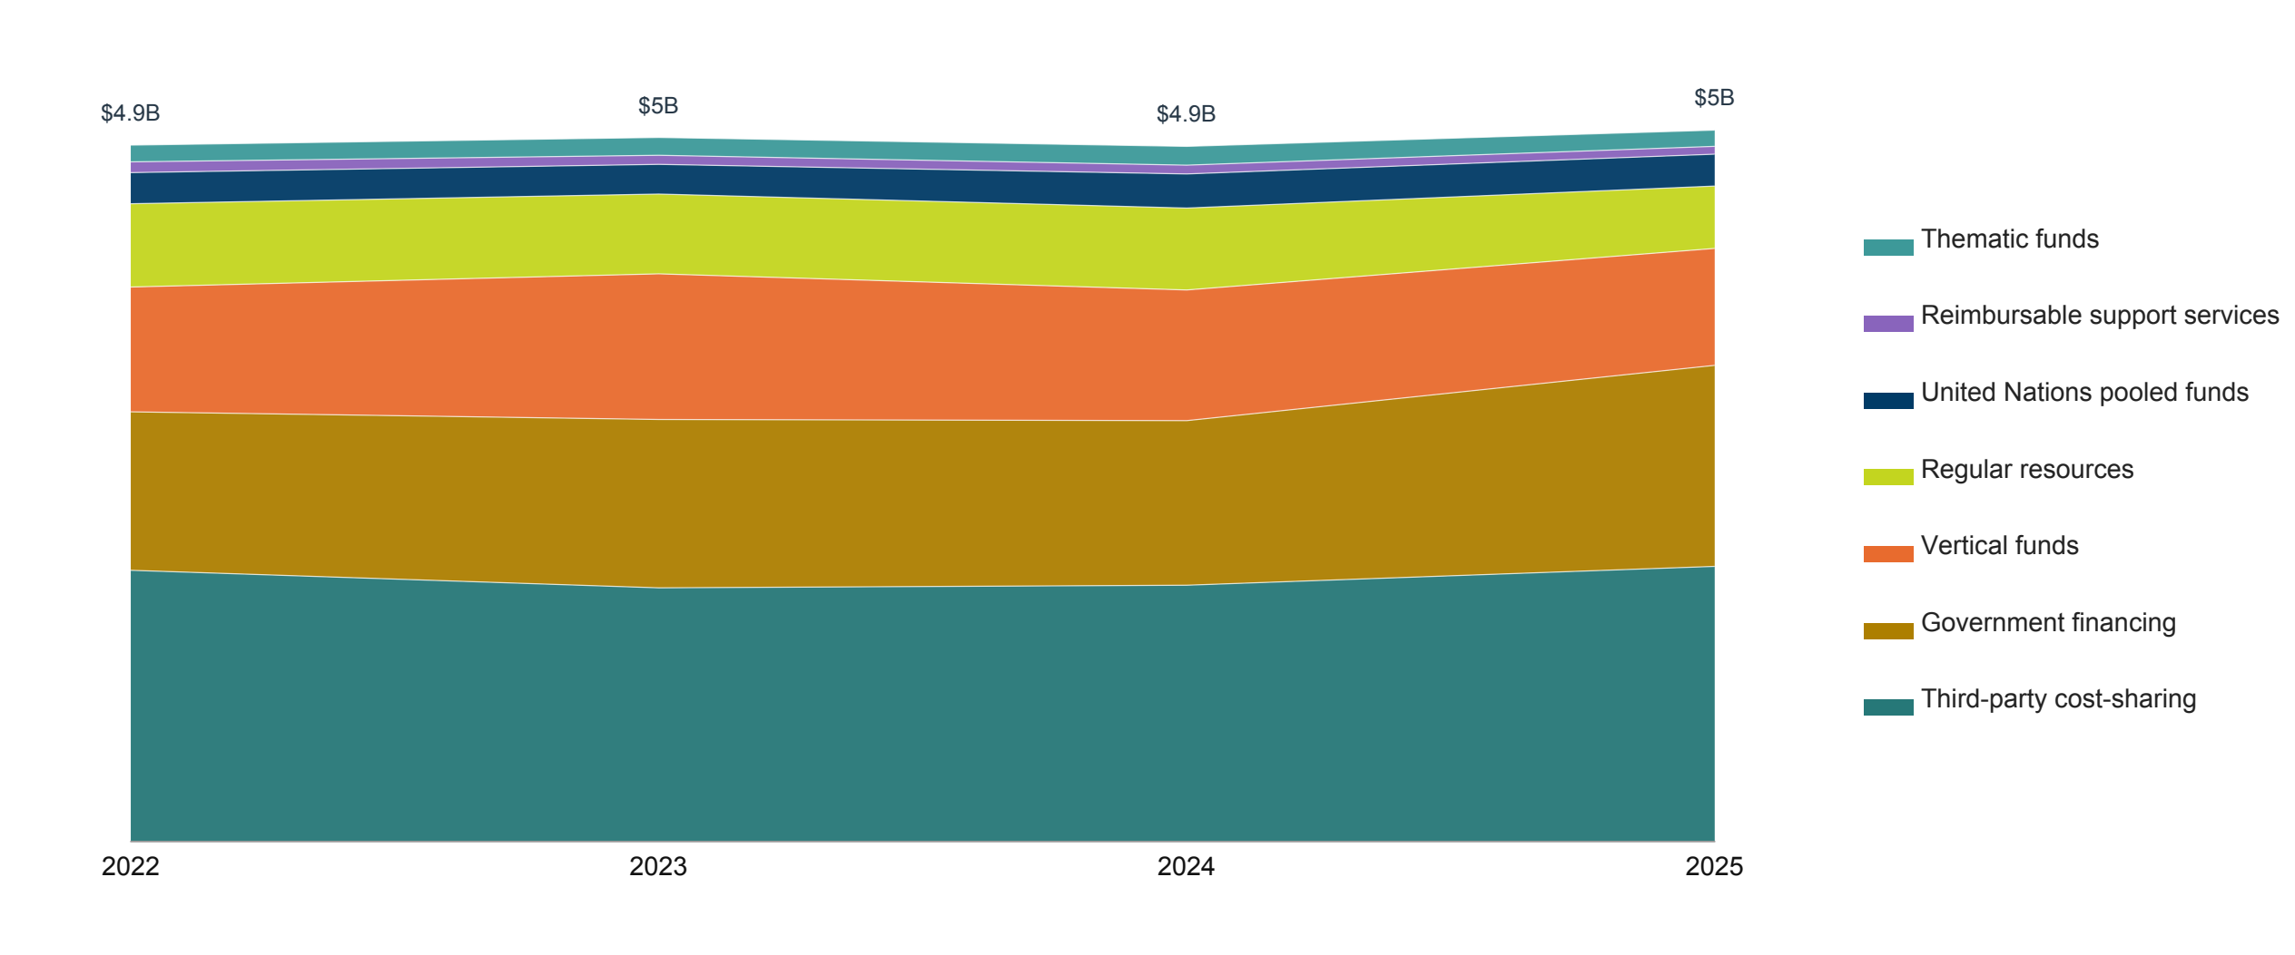

Regular (core) resources
Unearmarked funds that provide a flexible foundation for delivering results across the Strategic Plan.

Other resources
Earmarked funds that support specific themes, programmes or projects.
These include:

Government financing
Voluntary funding through which programme country governments entrust domestic resources or loans from financial institutions to UNDP to support development initiatives in their respective countries.

Thematic funds
Softly earmarked pooled funds that support the achievement of outcomes aligned with the Strategic Plan and address issues that cut across thematic areas.

Third-party cost-sharing
Earmarked contributions for a specific programme, project, region, or country.

Vertical funds
Earmarked funds focused on a single area of development, such as health or the environment.

UN pooled funds
UN inter-agency financing mechanisms that support clearly defined programmatic scopes and results frameworks, enabling global and local responses to humanitarian, development, environmental and peace-related challenges.

Reimbursable support services
Funds received for management and support services, including services provided by UN Volunteers and the Junior Professional Officer (JPO) Programme.

Regular resources

83%

Least developed countries
Share of core resources allocated where development needs are greatest.

78%

Low-income countries
Share of core resources allocated to low-income countries.

68%

Largest share to Africa
Share of programmatic resources allocated across the
region.

The case for core resources in 2025

Flexible foundation for impact
Core funding provides UNDP with flexible, predictable resources that enable it to respond rapidly to emerging challenges while maintaining a focus on long-term development goals in 170 countries and territories.

Reaching those most in need
The lion’s share of the core programme budget is channelled through country programmes. In 2022–2025, over 80 percent of these resources (TRAC-1, TRAC-2 and TRAC-3) were allocated to least developed countries, and over 70 percent to low-income countries, prioritizing the “last mile”—the poorest and most excluded populations.

Multiplier effect
Core funding is a smart investment and acts as a catalyst for additional investment.

Crisis readiness and response
UNDP spends 52 percent of its resources in fragile contexts, investing in all 61 countries defined as fragile by the OECD. Core resources enable early warning analysis, crisis prevention advocacy and immediate responses to conflicts and disasters. In Ukraine, UNDP's core-funded presence supported the assessment of 94,000 km² of potentially mine-contaminated land, including over 36,000 km² of agricultural land, while expanding access to digital public services for 466,101 internally displaced people and strengthening both recovery and resilience.

Pioneering innovative approaches to development
Core funding enables UNDP to push the boundaries on frontier development issues. For example, it supports the Accelerator Labs Network across 115 countries, which has identified more than 6,000 grass-roots solutions to development challenges.

Governance and electoral support
From 2022–2025, UNDP supported processes involving 911.3 million registered voters across 78 elections in 51 countries. In the Philippines, for example, core funding enabled UNDP to support the uptake of digital tools to increase transparency in campaign financing and strengthen voter education, reaching 2,260 voters, including youth, women, Indigenous communities and traditional leaders.

Digital transformation
With core resources, UNDP helps countries harness digital technologies to improve governance, service delivery and inclusion. In 2025, UNDP supported digital transformation in over 130 countries, enabling 49 million people to benefit from digital services and technologies while helping governments strengthen digital public infrastructure and innovative solutions for sustainable development.

Climate action at scale
As the largest UN provider of climate assistance, UNDP helps nations strengthen their environmental commitments, secure vital financing and implement equitable energy transitions. Initially launched with core resources, UNDP's Climate Promise has grown to support 90 percent of developing countries in designing and implementing ambitious Nationally Determined Contributions.

Operational excellence
Core funding maintains UNDP’s global infrastructure and quality standards, supporting independent oversight functions, including evaluation, ethics and development effectiveness. In 2024, UNDP received its 20th consecutive clean audit from the UN Board of Auditors, having stewarded over $100 billion in total revenue over 20 years while maintaining the highest standards of accountability and transparency.

Efficiency across the UN system
Core resources also drive greater efficiency and improve coordination across the entire UN system. UNDP is the single largest contributor to the UN Resident Coordinator System. It delivers dependable services to over 70 UN entities and manages 136 UN common premises globally, providing common services at the country level.

Trust and transformation
By investing in core funding, partners support a model that promotes national agency, reduces dependency and creates lasting, transformative change.

Lion’s share goes to programmes
The lion’s share of the core programme budget for 2022–2025 is channelled through country programmes.
GRAPH PLACEHOLDER
Lion’s share goes to programmes
Svg file name regular-resources-allocation

Strong support for least developed and low-income countries
Over 80 percent of core resources are allocated to least developed countries where development needs are greatest, and 78 percent to low-income countries.
2022–2025 distribution of regular (core) resources by development status
Core: TRAC-1, TRAC-2 and TRAC-3
GRAPH PLACEHOLDER
Strong support for least developed and low-income countries
Svg file name resources-by-development-status

2022–2025 distribution of regular (core) resources by country typology
Core: TRAC-1, TRAC-2 and TRAC-3
GRAPH PLACEHOLDER
Strong support for least developed and low-income countries
Svg file name resources-by-country-typology

Africa receives the largest share
In line with development needs, the largest share of core resources is allocated to Africa,
followed by Asia and the Arab States.
2022–2025 distribution of regular (core) resources by region
Core: TRAC-1, TRAC-2 and TRAC-3
GRAPH PLACEHOLDER
Africa receives the largest share
Svg file name resources-by-region

The institutional budget enables programmatic impact
UNDP’s institutional budget supports investments in institutional capacity, development effectiveness, the maintenance of the highest levels of independent oversight, transparency and accountability, and special-purpose initiatives (UNV and UNCDF).
GRAPH PLACEHOLDER
The institutional budget enables programmatic impact
Svg file name institutional-budget-allocation

Core contributors
In 2025, UNDP received $442 million in core contributions, of which 37 percent
were backed by multi-year commitments, down from 40 percent in 2024.
GRAPH PLACEHOLDER
Core contributors
Svg file name top-core-contributors

*Includes core contributions for 2024 received in 2025 **Includes core contributions for 2026 received in 2025

Partners with multi-year pledges to regular resources
In 2025, UNDP received $442 million in core contributions, of which 37 percent were backed by multi-year commitments, down from 40 percent in 2024.
Australia had a multi-year core agreement in 2025 but did not contribute to core funding.

Regular resources income from multi-year pledges
GRAPH PLACEHOLDER
Regular resources income from multi-year pledges
Svg file name multi-year-pledges

Government contributions to local office costs
Annual government contributions to local office costs (GLOC) are an important source of revenue and take the form of cash or in-kind contributions from host governments. In low- and middle-income countries, $39 million was received in 2025 (up from $29 million in 2024), consisting of $31 million in cash contributions and $8 million of in-kind contributions for premises and utilities.
GRAPH PLACEHOLDER
Government contributions to local office costs
Svg file name top-gloc-contributors

Other resources and partnerships
In 2025, annual contributions to
other resources increased to $4.6 billion,
up by 6 percent from $4.3 billion in 2024.
Other resources are earmarked contributions that supplement regular or core resources.

Top 20 other resources contributors, 2025
GRAPH PLACEHOLDER
Top 20 other resources contributors, 2025
Svg file name top-other-resources-contributors

Top 15 recipient countries of other resources, 2025
GRAPH PLACEHOLDER
Top 15 recipient countries of other resources, 2025
Svg file name top-15-recipient-countries-other-resources

Thematic funds
The funding windows remain UNDP’s principal flexible funding instrument after regular resources, providing critical support for integrated programming. In 2025, contributions to the funding windows declined to $115 million from $133 million in 2024. UNDP is grateful for the continued support of our partners for the funding windows.

Funding window contributions, 2022–2025
GRAPH PLACEHOLDER
Funding window contributions, 2022–2025
Svg file name thematic-window-contributions

Contributions by funding window and contributor
GRAPH PLACEHOLDER
Contributions by funding window and contributor
Svg file name funding-window-contributor-flow

UN pooled funds
A UN inter-agency pooled fund is a financing mechanism that supports a clearly defined programmatic purpose and results framework through contributions from more than one contributor. These funds enable global, regional and country-level responses to humanitarian, development, peace and transition and climate and environment-related challenges.
In 2025, UNDP remained the largest participating organization in inter-agency pooled funds, receiving $234 million, down by 7 percent from $251 million in 2024.

Top 15 UN pooled funds received by UNDP as a participating UN organization, 2025
GRAPH PLACEHOLDER
Top 15 UN pooled funds received by UNDP as a participating UN organization, 2025
Svg file name top-un-pooled-funds

Top 15 Member State Contributions and Share of Total Contributions to the top 15 Funds
GRAPH PLACEHOLDER
Top 15 Member State Contributions and Share of Total Contributions to the top 15 Funds
Svg file name top-pooled-fund-member-states

UN pooled funding to UNDP, 2022–2025
GRAPH PLACEHOLDER
UN pooled funding to UNDP, 2022–2025
Svg file name pooled-fund-contributions

Government development financing
Government development financing is a voluntary funding mechanism through which programme country governments entrust their domestic resources, or loans extended by international financial institutions (IFIs), to UNDP to assist in implementing development initiatives in their respective countries.

$1.4B
Total government financing in 2025,
representing 28 percent of total resources
and a 17 percent increase from 2024.

$113M
Financed through loans from
international financial institutions.

Government financing by country, 2025
GRAPH PLACEHOLDER
Government financing by country, 2025
Svg file name government-financing-by-country

Government financing by region
In 2025, programme countries in Latin America and the Caribbean contributed 62 percent of total government financing, followed by Africa (17 percent), Europe and the Commonwealth of Independent States (9 percent), the Arab States (8 percent), and Asia and the Pacific (4 percent).

Contributions to government financing, 2022–2025
GRAPH PLACEHOLDER
Contributions to government financing, 2022–2025
Svg file name government-financing-by-region

Vertical funds
Vertical funds are earmarked for a single area of development such as nature, climate, energy or health. These funds are governed by steering committees and are not directly administered by UNDP.
In 2025, UNDP received $825 million from vertical funds, an 11 percent decrease from the $920 million received in 2024. The largest contributions came from the Global Environment Facility ($372 million), the Global Fund ($311 million) and the Green Climate Fund ($84 million).

Vertical fund contributions, 2024–2025
GRAPH PLACEHOLDER
Vertical fund contributions, 2024–2025
Svg file name vertical-fund-contributions

Third-party cost-sharing
Earmarked contributions to a specific programme or project continue to account for the largest share of UNDP resources. In 2025, these contributions amounted to $1.95 billion (39 percent of total resources).

Partnering with the European Union
As UNDP’s third-largest donor in 2025, the European Union remains a strong partner. It contributed $313 million for UNDP programmes in Türkiye, Lebanon, Nigeria, Cyprus, Bosnia and Herzegovina, the Philippines and other countries, a 3 percent increase from the $305 million received in 2024.

Contributions from the European Union, 2022–2025
GRAPH PLACEHOLDER
Contributions from the European Union, 2022–2025
Svg file name eu-contributions-by-region

Partnering with financing institutions
UNDP’s financial and non-financial partnerships with IFIs are central to promoting $1 trillion in public expenditure and private capital investments aligned with the SDGs.
In 2025, UNDP received $316 million from IFIs, an 8 percent decrease from $344 million in 2024. The top IFI contributors were Kreditanstalt für Wiederaufbau (KfW) at $105 million and the World Bank at $88 million. This funding comprised $203 million in direct grants and $113 million in indirect government contributions.

Total contributions by IFI, 2025
GRAPH PLACEHOLDER
Total contributions by IFI, 2025
Svg file name ifi-contributions-donut

IFI contributions by type, 2022–2025
GRAPH PLACEHOLDER
IFI contributions by type, 2022–2025
Svg file name ifi-contributions-by-type

Top 10 recipients of IFI funding, 2025
GRAPH PLACEHOLDER
Top 10 recipients of IFI funding, 2025
Svg file name top-ifi-recipient-countries

Partnering with private companies, foundations, NGOs and academic institutions
Contributions from the private sector, foundations, non-governmental organizations and academic, training and research institutions decreased to $89 million in 2025, down by 5 percent from $94 million in 2024.
Partnerships with the private sector accelerate progress towards the SDGs by mobilizing capital, innovation and technology. Through its Finance Moonshot, UNDP leveraged $920 billion in public and private finance for the SDGs, helping countries mobilize investment for development priorities. Through the timbuktoo initiative, a flagship partnership to mobilize capital for innovation across Africa, UNDP is working to raise $1 billion over the next decade to support 10,000 start-ups and scale 1,000 ventures to generate $10 billion and positively impact 100 million lives.

Top 10 contributors, 2025
GRAPH PLACEHOLDER
Top 10 contributors, 2025
Svg file name top-private-sector-contributors

Annual contributions, 2022–2025
GRAPH PLACEHOLDER
Annual contributions, 2022–2025
Svg file name private-sector-contributions-by-type

*Corporate foundations are included under private companies.

Support to United Nations system programmes, offices and initiatives
In 2025, UNDP continued to serve as the institutional platform for four UN entities, delivering critical services across the UN system.

- The UN Volunteers programme promotes volunteerism to support peace and development worldwide. During 2025, 17,169 UN Volunteers from 182 countries supported 59 partner UN entities in their peace and development activities in 172 countries.
- In 2025, the UN Capital Development Fund provided $6 million in loans and $3.1 million in guarantees, leveraging and catalysing a total of $50 million in financing to support development solutions in 19 countries. Through UNCDF-enabled solutions, 3.3 million people were reached, of whom two-thirds were women.
- In 2025, the UN Office for South–South Cooperation supported 41 UN resolutions and decisions that incorporated South–South and triangular cooperation modalities. It also facilitated the implementation of South–South and triangular cooperation trust fund projects across 50 developing countries.
- The Multi-Partner Trust Fund Office transferred $1.06 billion to participating UN and non-UN entities in 2025, supporting development, climate and environment, and peace and transition outcomes for sustainable development progress. As a system-wide UN asset, the MPTF disbursed over $860 million to 41 UN entities and 111 countries in 2025
- .

Support to United Nations organizations: UNDP continued to be the operational backbone of the UN system in 2025. It disbursed $2.3 billion in 109 currencies through its payroll system, 54 percent of which was on behalf of partner UN organizations. UNDP supported $3.2 billion in financial transactions for 70 UN entities and other agencies in 170 countries. In addition, UNDP provided common premises for other agencies in 130 countries, enabling them to access common services, including travel management.

ANNUAL CONTRIBUTIONS TO UNDP, 2025
Contributions to UNDP from non-Member State partner groups
Non-Member State partner group | Regular | Other | Total
European Union | — | $312,784,472 | —
Financial Institutionsᵃ | — | $98,363,895 | —
Other Multilaterals | — | $11,019,073 | —
Private companies | — | $39,816,444 | —
Foundations | — | $28,967,314 | —
NGOs | — | $19,918,648 | —
Academic, training and research institutions | — | $728,344 | —
UN Agencies | — | $69,396,342 | —
UN pooled funds | — | $233,741,124 | —
Vertical Funds | — | $825,262,999 | —
Others | — | $377,220 | —
Total non-Member State partner groups | — | $1,640,375,875 | —
2025 contributions totalᵇ | $442M | $4,598M | $5,040M

Notes
a. Reflects direct grants received by UNDP; excludes loans extended to programme country governments and received by UNDP as government financing, and grants received from the German Development Bank (KfW), which are reported under Germany.
b. Amounts are rounded to the nearest million. Includes core contributions for 2024 received in 2025 and core contributions for 2026 received in 2025.

Annual contributions to UNDP from Member States, 2025
Amounts in US dollars.
Member State | Regular | Donor cost-sharing | Govt. financing | Trust funds | Reimbursable | Subtotal | Local office | NCC | Upper MIC | In-kind | Total
Albania | - | - | 300,112 | - | - | 300,112 | 296,204 | - | - | - | 596,316
Algeria | - | - | - | 10,000 | - | 10,000 | 550,000 | - | - | - | 560,000
Angola | - | - | 32,689,568 | - | - | 32,689,568 | 2,050,960 | - | - | 199,264 | 34,939,791
Argentina | - | - | 305,771,408 | 10,000 | - | 305,781,408 | - | 663,586 | - | - | 306,444,994
Armenia | - | - | 815,470 | - | - | 815,470 | 155,000 | - | - | 508,993 | 1,479,463
Australia | - | 32,896,259 | - | - | 1,366,049 | 34,262,307 | - | - | - | - | 34,262,307
Austria | 1,409,249 | 5,465,207 | - | - | - | 6,874,455 | - | - | - | - | 6,874,455
Azerbaijan | - | - | - | 15,000 | - | 15,000 | - | - | - | - | 15,000
Bahamas | - | - | - | - | 23,070 | 23,070 | - | - | - | - | 23,070
Bahrain | - | - | 150,000 | - | - | 150,000 | - | 945,322 | - | 152,390 | 1,247,712
Bangladesh | - | 1,186,748 | 1,120,000 | 15,000 | 4,000 | 2,325,748 | - | - | - | - | 2,325,748
Barbados | - | - | - | - | - | - | - | - | - | 346,412 | 346,412
Belarus | - | - | 1,427,203 | - | - | 1,427,203 | 261,179 | - | - | 93,540 | 1,781,922
Belgium | 11,560,694 | 4,841,536 | - | - | 130,035 | 16,532,264 | - | - | - | - | 16,532,264
Belize | - | - | - | - | 1,500 | 1,500 | 98,901 | - | - | 9,293 | 109,694
Benin | - | - | 6,263,745 | - | - | 6,263,745 | - | - | - | 96,688 | 6,360,432
Bhutan | - | - | 285,484 | - | - | 285,484 | 236,328 | - | - | 47,440 | 569,252
Bolivia, Plurinational State of | - | - | 15,066,996 | - | - | 15,066,996 | 447,582 | - | - | - | 15,514,578
Bosnia and Herzegovina | - | - | 7,056,013 | - | - | 7,056,013 | 745,871 | - | - | - | 7,801,884
Botswana | - | - | 1,249,502 | - | - | 1,249,502 | 113,250 | - | - | 103,180 | 1,465,932
Brazil | - | 3,765,147 | 71,738,041 | - | - | 75,503,188 | - | - | 528,443 | - | 76,031,631
Burundi | - | - | 396,910 | - | - | 396,910 | - | - | - | 129,997 | 526,907
Cambodia | 10,000 | - | 60,156 | 4,000 | - | 74,156 | 86,327 | - | - | - | 160,483
Cameroon | - | - | 11,371,325 | - | - | 11,371,325 | - | - | - | - | 11,371,325
Canada | 29,325,513 | 57,023,478 | - | 910,532 | 698,324 | 87,957,847 | - | - | - | - | 87,957,847
Cape Verde | - | - | - | - | - | - | 151,062 | - | - | - | 151,062
Central African Republic | - | - | 8,020,978 | - | - | 8,020,978 | - | - | - | - | 8,020,978
Chad | - | - | 237,340 | - | - | 237,340 | - | - | - | - | 237,340
Chile | - | - | 9,387,963 | 5,000 | - | 9,392,963 | - | 894,972 | - | 495,083 | 10,783,018
China | 3,450,000 | 398,782 | 23,027,805 | 2,298,000 | 2,534,560 | 31,709,147 | - | - | 2,684,522 | - | 34,393,669
Colombia | - | 39,086 | 73,520,221 | 210,000 | - | 73,769,307 | 270,000 | - | - | - | 74,039,307
Congo (the) | - | - | 465,603 | - | - | 465,603 | - | - | - | - | 465,603
Costa Rica | - | - | 90,618 | - | - | 90,618 | - | - | 771,359 | - | 861,977
Côte d'Ivoire | - | - | - | - | - | - | 1,027,149 | - | - | 112,281 | 1,139,430
Croatia | - | 3,800 | - | - | - | 3,800 | - | - | - | - | 3,800
Cuba | - | - | 36,997,822 | - | - | 36,997,822 | - | - | - | - | 36,997,822
Cyprus | 58,500 | - | 4,922,200 | - | - | 4,980,700 | - | - | - | 50,787 | 5,031,487
Czech Republic | - | 1,048,948 | - | - | 429,886 | 1,478,834 | - | - | - | - | 1,478,834
Democratic People’s Republic of Korea | - | - | - | - | - | - | 25,145 | - | - | 62,809 | 87,954
Democratic Republic of the Congo | - | - | - | - | - | - | 556,368 | - | - | - | 556,368
Denmark | 19,104,386 | 48,737,541 | - | 34,387,895 | 3,373,233 | 105,603,056 | - | - | - | 3,701,657 | 109,304,713
Djibouti | - | - | 1,340,720 | - | - | 1,340,720 | 226,808 | - | - | - | 1,567,528
Dominica | - | - | 42,569,514 | - | - | 42,569,514 | - | - | - | - | 42,569,514
Dominican Republic | - | 198,191 | 17,459,120 | - | - | 17,657,311 | 69,117 | - | 654,313 | 104,963 | 18,485,705
Ecuador | - | 13,889 | 6,421,844 | - | - | 6,435,733 | 772,340 | - | - | - | 7,208,073
Egypt | - | - | 31,163,880 | - | - | 31,163,880 | 660,597 | - | - | - | 31,824,476
El Salvador | - | - | 315,430 | - | 39,432 | 354,862 | 339,968 | - | - | - | 694,830
Equatorial Guinea | - | - | 3,901,168 | - | - | 3,901,168 | - | - | - | - | 3,901,168
Eritrea | - | - | - | - | - | - | 133,502 | - | - | - | 133,502
Estonia | - | 130,719 | - | - | - | 130,719 | - | - | - | - | 130,719
Eswatini | - | - | 1,577,022 | - | - | 1,577,022 | 221,306 | - | - | - | 1,798,328
Ethiopia | - | - | 14,306,534 | - | - | 14,306,534 | 235,556 | - | - | - | 14,542,089
Fiji | - | - | 1,501,027 | - | - | 1,501,027 | 388,169 | - | - | - | 1,889,196
Finland | 1,169,591 | 13,356,448 | - | - | 476,509 | 15,002,548 | - | - | - | - | 15,002,548
France | - | 7,214,741 | - | - | 1,624,661 | 8,839,401 | - | - | - | - | 8,839,401
Gabon | - | - | 123,262,922 | - | - | 123,262,922 | 248,779 | - | - | 345,654 | 123,857,354
Gambia | - | - | 3,318,385 | - | - | 3,318,385 | - | - | - | - | 3,318,385
Georgia | - | - | - | - | - | - | 202,670 | - | - | 430,360 | 633,030
Germany | 105,197,907 | 168,717,361 | - | 48,491,980 | 4,392,527 | 326,799,775 | - | - | - | 912,094 | 327,711,869
Ghana | - | - | - | - | - | - | - | - | - | 293,598 | 293,598
Greece | - | 57,149 | - | - | - | 57,149 | - | - | - | - | 57,149
Guatemala | - | - | 98,091,888 | - | - | 98,091,888 | 654,913 | - | - | - | 98,746,801
Guinea | - | - | 289,094 | - | - | 289,094 | - | - | - | - | 289,094
Guyana | - | - | - | - | - | - | 129,944 | - | - | 198,060 | 328,004
Haiti | - | - | 40,688,876 | - | - | 40,688,876 | 141,519 | - | - | - | 40,830,395
Honduras | - | - | 43,388,032 | - | - | 43,388,032 | 39,157 | - | - | - | 43,427,188
Hungary | - | 23,474 | - | - | - | 23,474 | - | - | - | - | 23,474
Iceland | 238,186 | 1,500,173 | - | 2,603,443 | - | 4,341,802 | - | - | - | - | 4,341,802
India | 4,248,772 | - | 18,448,555 | 1,000,000 | 20,000 | 23,717,327 | 159,124 | - | - | 290,373 | 24,166,823
Indonesia | - | - | 19,242,852 | 10,000 | - | 19,252,852 | 1,020,358 | - | - | 13,027 | 20,286,236
Iran, (Islamic Republic of) (the) | - | - | 73,000 | - | - | 73,000 | 3,606 | - | - | - | 76,606
Iraq | - | - | 305,344 | - | - | 305,344 | 2,719,788 | - | - | - | 3,025,132
Ireland | 8,959,538 | 8,262,783 | - | - | 1,329,480 | 18,551,800 | - | - | - | - | 18,551,800
Italy | - | 57,097,155 | - | - | 1,292,687 | 58,389,842 | - | - | - | - | 58,389,842
Jamaica | - | - | - | - | - | - | 129,013 | - | - | 90,689 | 219,702
Japan | 45,391,094 | 197,979,375 | - | 990,099 | 9,775,532 | 254,136,100 | - | - | - | 146,680 | 254,282,780
Jordan | - | 451,977 | 3,378,980 | - | - | 3,830,958 | 398,484 | - | - | - | 4,229,442
Kazakhstan | - | 150,000 | 11,245,327 | - | 744,539 | 12,139,866 | - | - | 1,300,000 | 279,526 | 13,719,392
Kenya | - | - | - | - | - | - | 495,528 | - | - | - | 495,528
Kosovo* | - | - | 2,103,875 | - | - | 2,103,875 | - | - | - | - | 2,103,875
Kuwait | 570,000 | 10,426,631 | 622,339 | - | - | 11,618,970 | - | 1,954,397 | - | 313,023 | 13,886,390
Kyrgyzstan | - | - | - | - | - | - | - | - | - | 242,657 | 242,657
Lao People’s Democratic Republic | - | - | - | - | - | - | 70,120 | - | - | 186,136 | 256,256
Latvia | - | 147,224 | - | - | - | 147,224 | - | - | - | - | 147,224
Lebanon | - | - | 185,964 | - | - | 185,964 | 968,402 | - | - | - | 1,154,366
Lesotho | - | 73,558 | 42,436 | - | - | 115,994 | 120,716 | - | - | 235,679 | 472,389
Liberia | - | - | 1,792,495 | - | - | 1,792,495 | - | - | - | - | 1,792,495
Libya | - | - | 100,299 | - | - | 100,299 | - | - | - | - | 100,299
Liechtenstein | 60,729 | 422,573 | - | - | - | 483,301 | - | - | - | - | 483,301
Luxembourg | 3,685,532 | 6,434,034 | - | 3,127,118 | 216,813 | 13,463,496 | - | - | - | - | 13,463,496
Madagascar | - | - | - | - | - | - | 189,290 | - | - | - | 189,290
Malawi | - | - | - | - | - | - | - | - | - | 71,274 | 71,274
Malaysia | - | - | 2,062,363 | - | - | 2,062,363 | - | - | 384,615 | 1,071,091 | 3,518,070
Maldives | - | 15,000 | 23,333 | - | - | 38,333 | - | - | 430,508 | - | 468,841
Mali | - | - | 66,824 | - | - | 66,824 | 347,374 | - | - | 32,677 | 446,875
Marshall Islands | - | - | - | - | - | - | 314,024 | - | - | - | 314,024
Mauritania | - | - | 7,332,691 | - | - | 7,332,691 | - | - | - | - | 7,332,691
Mauritius | - | - | 445,116 | - | - | 445,116 | - | - | 419,731 | - | 864,847
Mexico | - | 272,368 | 8,401,260 | - | - | 8,673,628 | - | - | 1,100,000 | - | 9,773,628
Micronesia (Federated States of) | - | - | - | - | - | - | 30,000 | - | - | - | 30,000
Mongolia | - | 49,982 | 1,223,073 | - | - | 1,273,055 | 97,916 | - | - | 77,543 | 1,448,514
Montenegro | - | - | 20,266,471 | - | - | 20,266,471 | - | - | 476,140 | 213,716 | 20,956,327
Montserrat d/ | - | - | - | - | - | - | 6,189 | - | - | - | 6,189
Morocco | 488 | - | 21,701,618 | - | - | 21,701,130 | 133,813 | - | - | - | 21,834,943
Mozambique | - | - | 556,479 | - | - | 556,479 | - | - | - | 188,266 | 744,745
Myanmar | - | - | - | - | - | - | - | - | - | 76,871 | 76,871
Namibia | - | - | - | - | - | - | 460,589 | - | - | 323,872 | 784,460
Nauru | - | - | - | - | - | - | 23,986 | - | - | - | 23,986
Nepal | - | - | 3,726,315 | - | - | 3,726,315 | 171,326 | - | - | - | 3,897,641
The Netherlands | 37,037,037 | 49,607,429 | - | - | 137,237 | 86,781,703 | - | - | - | - | 86,781,703
New Zealand | 4,793,289 | 19,072,593 | - | - | 246 | 23,866,129 | - | - | - | - | 23,866,129
Niger | - | - | 1,634,475 | - | - | 1,634,475 | - | - | - | 446,129 | 2,080,605
Nigeria | - | - | 6,847,605 | - | 104,492 | 6,952,097 | - | - | - | 324,560 | 7,276,657
Niue | - | - | - | - | - | - | 23,212 | - | - | - | 23,212
Norway | 37,343,097 | 224,612,165 | - | - | 850,883 | 262,806,144 | - | - | - | - | 262,806,144
Pakistan | - | 15,242 | 2,658,303 | - | - | 2,673,545 | 854,825 | - | - | - | 3,528,370
Palestine (State of) | - | - | 1,999,566 | - | - | 1,999,566 | - | - | - | - | 1,999,566
Panama | - | 226,648 | 47,195,679 | - | - | 47,422,327 | - | 670,802 | - | - | 48,093,129
Papua New Guinea | - | - | 835,590 | - | - | 835,590 | - | - | - | - | 835,590
Paraguay | - | - | 17,316,658 | - | - | 17,316,658 | - | - | - | - | 17,316,658
Peru | - | - | 9,865,238 | - | - | 9,865,238 | 614,971 | - | - | - | 10,480,209
Philippines | 10,000 | 15,000 | 465,331 | 30,000 | - | 520,331 | 737,230 | - | - | - | 1,257,562
Poland | - | 1,133,819 | - | - | - | 1,133,819 | - | - | - | - | 1,133,819
Portugal | 50,000 | 74,298 | - | - | 310,238 | 434,535 | - | - | - | - | 434,535
Qatar | 8,000,000 | 47,124,296 | - | - | - | 55,124,296 | - | - | - | - | 55,124,296
Republic of Korea | 15,370,924 | 120,189,862 | - | 5,188,193 | 6,186,168 | 146,935,147 | - | - | - | 35,105 | 146,970,252
Republic of Moldova | - | - | 340,595 | - | - | 340,595 | 241,701 | - | - | 112,254 | 694,550
Republic of North Macedonia | - | - | 9,165,139 | - | - | 9,165,139 | - | - | - | - | 9,165,139
Romania | - | 235,294 | - | - | - | 235,294 | - | - | - | - | 235,294
Russian Federation | - | 829,010 | - | 1,061,997 | 2,975,032 | 4,866,039 | - | - | - | - | 4,866,039
Rwanda | - | - | - | - | - | - | 123,065 | - | - | 91,696 | 214,761
Saint Vincent and the Grenadines | - | - | - | - | - | - | 8,784 | - | - | - | 8,784
Samoa (1) | 6,000 | - | - | - | - | 6,000 | 191,754 | - | - | 55,054 | 252,808
Sao Tome and Principe | - | - | 3,498,016 | - | - | 3,498,016 | - | - | - | - | 3,498,016
Saudi Arabia | 2,000,000 | 52,082,197 | 40,623,288 | - | - | 94,705,485 | - | 2,400,000 | - | 204,247 | 97,309,732
Senegal | - | - | 115,408 | - | - | 115,408 | - | - | - | 60,171 | 175,579
Serbia | - | 3,238,041 | 20,583,841 | - | 10,816 | 23,832,698 | 302,903 | - | 263,668 | 477,546 | 24,876,815
Seychelles | - | - | - | - | - | - | - | 75,000 | - | - | 75,000
Sierra Leone | - | - | 1,982,726 | - | - | 1,982,726 | - | - | - | - | 1,982,726
Sikkim | - | - | 33,372 | - | - | 33,372 | - | - | - | - | 33,372
Singapore | 300,000 | 1,045,000 | - | - | - | 1,345,000 | - | - | - | 141,395 | 1,486,395
Slovak Republic | - | 3,711,148 | - | - | - | 3,711,148 | - | - | - | - | 3,711,148
Slovenia | - | 34,762 | - | - | - | 34,762 | - | - | - | - | 34,762
Solomon Islands | - | - | 472,716 | - | - | 472,716 | 124,193 | - | - | - | 596,909
South Africa | - | - | - | 1,011,237 | - | 1,011,237 | 1,561,569 | - | - | 133,381 | 2,706,186
South Sudan | - | - | 1,786,216 | - | - | 1,786,216 | 4,104,243 | - | - | - | 5,890,459
Spain | 7,638,073 | 21,931,293 | - | 232,558 | 6,957,713 | 36,759,636 | - | - | - | - | 36,759,636
Sri Lanka | - | - | 98,238 | - | - | 98,238 | 151,974 | - | - | 256,720 | 506,932
Sudan (the) | - | - | 7,551,785 | - | - | 7,551,785 | - | - | - | - | 7,551,785
Suriname | - | - | - | - | 41,647 | 41,647 | - | - | - | 31,442 | 73,089
Sweden | 40,911,333 | 87,398,241 | - | 20,410,326 | 3,073,584 | 151,793,485 | - | - | - | - | 151,793,485
Switzerland | 38,608,749 | 27,251,199 | - | 1,735,000 | 2,237,399 | 69,832,347 | - | - | - | - | 69,832,347
Tajikistan | - | - | 53,949 | - | - | 53,949 | 140,000 | - | - | 302,192 | 496,141
Thailand | 865,112 | 184,742 | 1,036,936 | 5,000 | 1,533 | 2,093,322 | 479,293 | - | - | - | 2,572,616
Timor0Leste | - | - | 1,376,260 | 1,100 | - | 1,377,360 | 136,355 | - | - | 350,330 | 1,864,046
Togo | - | - | - | - | - | - | - | - | - | 184,521 | 184,521
Tokelau | - | - | 113,865 | - | - | 113,865 | 34,361 | - | - | - | 148,226
Tonga | - | - | - | - | - | - | 34,468 | - | - | 3,383 | 37,851
Trinidad and Tobago | - | - | 2,500,000 | 2,000 | - | 2,502,000 | - | 1,259,545 | - | - | 3,761,545
Tunisia | - | - | 492,237 | - | - | 492,237 | - | - | - | - | 492,237
Türkiye | 1,200,000 | 1,800,000 | 17,306,547 | 70,000 | 10,000 | 20,386,547 | - | - | 705,000 | - | 21,091,547
Turkmenistan | - | - | 22,562,688 | - | - | 22,562,688 | - | - | - | 229,713 | 22,792,402
Tuvalu | - | - | - | - | - | - | - | - | - | 25,213 | 25,213
Uganda | - | - | - | - | - | - | 156,957 | - | - | - | 156,957
Ukraine | - | - | 1,279,343 | - | - | 1,279,343 | - | - | - | 308,965 | 1,588,308
United Arab Emirates | - | 500,000 | - | - | - | 500,000 | - | - | - | - | 500,000
United Kingdom | 14,666,667 | 59,671,045 | - | 1,658,941 | 79,733 | 76,076,386 | - | - | - | - | 76,076,386
United Republic of Tanzania | - | - | 2,829,985 | - | 142,515 | 2,972,500 | - | - | - | 563,763 | 3,536,263
United States of America | - | -9,125,096 | - | -2,115 | -1,866,445 | -10,993,656 | - | - | - | - | -10,993,656
Uruguay | - | 40,924 | 36,185,979 | - | 2,864 | 36,229,767 | - | 704,373 | - | - | 36,934,140
Uzbekistan | - | - | 5,773,721 | - | - | 5,773,721 | - | - | - | 741,048 | 6,514,770
Vanuatu | - | - | 750,000 | - | - | 750,000 | - | - | - | - | 750,000
Venezuela, Bolivarian Republic of | - | - | 324,758 | - | - | 324,758 | - | - | - | - | 324,758
Viet Nam | 70,000 | - | 36,793 | - | - | 106,793 | 491,390 | - | - | - | 598,183
Zambia | - | - | 13,297,705 | - | - | 13,297,705 | 141,658 | - | - | - | 13,439,363
Zimbabwe | - | - | - | 1,000 | - | 1,000 | 472,745 | - | - | - | 473,745
TOTAL e/ | 443,309,481 | 1,341,300,491 | 1,446,365,501 | 125,493,303 | 49,728,489 | 3,406,197,264 | 30,522,967 | 9,567,998 | 9,718,299 | 17,326,472 | 3,473,332,999

Notes
* All references to Kosovo in this table should be understood in the context of United Nations Security Council resolution 1244 (1999).
- For Fund 00001 only. Excludes amounts totalling $991,411 for which the donor is not identified.
- Includes South–South contributions from China ($18,635,831), Colombia ($100,000) and Saudi Arabia ($900,000).
- Amounts exclude accounting linkages.
- Montserrat is a programme country managed by the Barbados office.
- Includes JPOs, management service agreements (MSAs) and development service agreements.

